Digital transformation: from adult-education institution to Digital Education Enterprise

O3 - Business model for aligning the adults training programs to the needs and opportunities offered by the labour market and specific organisations upon producer’s model

February 09, 2023

Project data | Project title | Digital transformation: from adult-education institution to Digital Education Enterprise
 | Project acronym | Digital Education Enterprise
 | Project number | 2021-1-BG01-KA220-ADU-000026986
 | Project coordinator | E10142644 SBC School of Business Competences Ltd.
 | Partner organizations | E10268592 Mobiliz Bilgi ve İletişim Teknolojileri A.Ş.  E10209310 INSTITUTO TECNOLÓGICO DE CANARIAS, S.A. E10032547 DOREA EDUCATIONAL INSTITUTE WTF E10150580 BUSINESS & PROFESSIONAL WOMEN CR Z.S.
Result Data | Project result title | O3 - Business model for aligning the adults training programs to the needs and opportunities offered by the labor market and specific organizations upon producer’s model
 | Document category | Methodologies / guidelines. Co-operation processes and methodologies
 | Within responsibility of | [A] ITC, [C] Partners  Key to division of work:  R = Responsible – those who do the work to complete the task  A = Accountable - the one ultimately answerable for the correct and thorough completion of the deliverable or task  C = Consulted – those whose opinions are sought  I = Informed - Those who are up-to-date on progress
 | Date of issue | February 9, 2023
 | Version NN.NN | 00.01
 | Audience | Project partners, public under ERASMUS+ rules
Purpose and motivation | O3 is a business model for aligning the adult training programs to the needs and opportunities offered by the labor market and specific organizations upon producer’s model. O3 aims to change the traditional way employers use adult education and training services by aligning the real employers needs of competences with adult education organization propositions.  Target groups  - This project partners  - Adult education and training organizations commercial and in company  - Trade and/or industrial association, employers, and labor agencies searching for curricula aligned to their specific needs and labor market opportunities
Scope | O3-T1 Value propositions design  O3-T2 Business model design

Index

Chapter 1: Introduction to the purpose
Chapter 2: Terms and definitions
Chapter 3: Methodological framework
Chapter 4: Identification of target groups
4.1 Analysis of existing policies and trends. Upskilling and reskilling.
4.2 Target groups
Chapter 5: Value propositions
5.1 Trainees: Workers and unemployed;
5.2 Companies: Employers;
5.3 Public Administration;
5.5 Value Proposition: Conclusions
Chapter 6: Business model
6.1 Customer Segments
6.2 Value Propositions
6.3 Channels
6.4 Customer Relationships
6.5 Key Resources
6.6 Key Partnerships
6.7 Key Activities
6.8 Cost structure
6.9 Revenue Streams
Chapter 7 Summary
Bibliography
ANNEX1: Producer’s Model Business Case

Chapter 1: Introduction to the purpose

The project “Digital transformation: from adult-education institution to Digital Education Enterprise” has 4 outputs:
- O1 Digital Education Enterprise business model and processes
- O2 Digital Transformation Plan to reengineer the usual way of adult training and education to the Digital Education Enterprise business model
- O3 Business model for aligning the adults training programs to the needs and opportunities offered by the labor market and specific organizations upon producer’s model
- O4 Digital training manual how to implement O1 and O3 business models, and O2 Digital Transformation Plan and processes

This report is dedicated to the project’s output - O3 Business model for aligning the adults training programs to the needs and opportunities offered by the labor market and specific organizations upon producer’s model.

O3 aims to change the traditional way employers use adult education and training services by aligning the real employers needs of competences with adult education organization propositions.

Apart from the project partners, the project results are of interest to adult-education and training organizations – commercial and in-company; trade and/or industrial association, employers, and labour agencies searching for curricula aligned to their specific needs and labour market opportunities; Start-ups; VET and other educational organizations interested in new digital education business

Chapter 2: Terms and definitions

Business model
A business model describes the rationale of how an organization creates, delivers, and captures value. (1)

Business Model Canvas
The Business Model Canvas is a strategic management and entrepreneurial tool. It allows you to describe, design, challenge, invent and pivot your business model. (2)
The Business Model Canvas is licensed under the Creative Commons Attribution-Share Alike 3.0 Unported License. To view a copy of this license, visit: http://creativecommons.org/licenses/by-sa/3.0/ or send a letter to Creative Commons, 171 Second Street, Suite 300, San Francisco, California, 94105, USA.

Value proposition
The company’s core promise of benefits to clients and prospective clients. (3)

Value Proposition Canvas
The Value Proposition Canvas is a business tool that helps you tackle the core challenges of every business – creating compelling products and services customers want to buy. (4), (5)

Chapter 3: Methodological framework
The O3’s methodological framework for development is depicted in Figure 1.

 |  |  |  | 
Identification of existing programmes, training models, customer segments/ target groups |  | Design of O3-T1  Value propositions for each customer segment/ target group |  | Design of O3-T2  Business Model adapted to each Value Proposition

Figure 1 O3’s methodological framework for development

The O3’s development process starts with the identification of external and internal education/training customer segments (target groups).

Then 2 main tasks are performed:

O3-T1 Value propositions design
For the purpose The Value Proposition Canvas was used. For each target group was developed:
- Customer Profile, that presents target group understanding,
- Value Map, that presents how O3 intends to create value for that target group,
- The Value map’s products, services, pain relievers and gain creators that fit Customer Profile’s jobs, pains, and gains.

The result is a Value proposition for the relevant target group.

O3-T2 Business model design
For this purpose The Business Model Canvas is used.
- A business model was developed that produces and delivers the value proposition for each target group,
- This business model was created on the digital enterprise pillars (6) and considers how to align the adult training programs to the needs and opportunities offered by the labor market and specific organizations upon producer’s model .

Chapter 4: Identification of target groups

4.1 Analysis of existing policies and trends. Upskilling and reskilling.
There is often a mismatch between the training organisations, the adult education and training offers and the actual demand of the industry. Many EU organisations struggle with the lack of skilled staff. Many businesses require a steady influx of new workers. The hiring costs are too high. If a new hire does not have the competence that the employer requires, the on-boarding time is long and the costs rise. That is why employers need cost-efficient methods for hiring and on-boarding new workers.
The European Union and its member states have been developing various policies that support training programs that are aligned with the real needs of the labour market.
On 24 November 2020, the Council of the EU adopted a Recommendation on vocational education and training for sustainable competitiveness, social fairness and resilience. The Recommendation establishes key principles for ensuring that vocational education and training is agile in that it quickly adapts to labour market needs and provides quality learning opportunities for both young people and adults.
It emphasises the increased flexibility of vocational education and training, enhanced opportunities for work-based learning, apprenticeships and improved quality assurance.

In October 2022 the Commission adopted its proposal to make 2023 the European Year of Skills.
The green and digital transitions are creating new opportunities for people and the EU economy. Having the relevant skills enables people to successfully cope with labour market changes and to fully participate in society and democracy.
This will ensure that no one is left behind and that the economic recovery as well as the green and digital transitions are socially fair and just.
A workforce with the skills that are in demand also contributes to sustainable growth, leads to more innovation and improves companies’ competitiveness. However, currently more than three quarters of companies in the EU report difficulties in finding workers with the necessary skills, and latest figures from Eurostat suggest that only 37% of adults undertake training on a regular basis.
The Digital Economy and Society Index shows that 4 out of 10 adults and every third person who works in Europe lack basic digital skills. In addition, already in 2021, 28 occupations ranging from construction and healthcare to engineering and IT had shortages, showing a growing demand for both high and low-skilled workers.
To encourage lifelong learning, Member States have endorsed the EU 2030 social targets that at least 60% of adults should participate in training every year, already presenting their national contribution to meeting this target.
This is also important to reach the employment rate target of at least 78% by 2030. The 2030 Digital Compass sets the EU target that by 2030, at least 80% of all adults should have at least basic digital skills, and there should be 20 million employed ICT specialists in the EU, while more women should be encouraged to take up such jobs.
The Commission proposes to give a fresh impetus to lifelong learning by:
- Promoting increased, and more effective and inclusive investment in training and upskilling to harness the full potential of the European workforce, and to support people in changing from one job to another.
- Making sure that skills are relevant for labour market needs, by also cooperating with social partners and companies.
- Matching people’s aspirations and skill sets with opportunities on the job market, especially for the green and digital transition and the economic recovery. A special focus will be given to activate more people for the labour market, in particular women and young people, especially those not in education, employment or training.
- Attracting people from third countries with the skills needed by the EU, including by strengthening learning opportunities and mobility and facilitating the recognition of qualifications.
To achieve these objectives, the Commission will support upskilling and reskilling opportunities.
The Pact for Skills is one of the key actions of the European Skills Agenda. The Pact aims to help public and private organisations with upskilling and reskilling, so they can succeed through the green and digital transitions.
The EU Digital Skills and Jobs Coalition addresses the digital skills gap by bringing together Member States, social partners, companies, non-profit organisations and education providers to raise awareness and encourage organisations to take different actions to promote digital skills training such as taking a pledge to improve digital skills.
Improving vocational education and training (VET) systems relies on high-quality and timely insights on job market dynamics and new skill demands. CEDEFOP (European Centre for the Development of Vocational Training) analyses how changing economic and social megatrends, such as workforce ageing and the digital and green transitions, generate new skill demands and skill mismatches and reshape the future of work in EU workplaces.
The Future of Jobs Report 2023, a report that presents information and data that were compiled and/or collected by the World Economic Forum, explores how jobs and skills will evolve over the next five years. This fourth edition of the series continues the analysis of employer expectations to provide new insights on how socio-economic and technology trends will shape the workplace of the future. Given that businesses see skills gaps in the local labour market as the main obstacle towards achieving industry transformation and investing in learning and training on the job as the most promising workforce strategy for achieving their business goals, this report considers that developing effective reskilling and upskilling strategies for the next five years is essential for maximising business performance.
Reskilling 4 Employment (R4E) was officially launched by the European Round Table for Industry (ERT) in May 2021. The goal of this pan-European programme is to serve as a hub that stimulates partnerships that provide reskilling opportunities to unemployed and ‘at-risk’ workers, so they can find employment in new occupations that are in-demand.
Reskilling means learning new skills and competencies to perform a different occupation or career path. Automation and digitisation are changing the nature of work and the demand for workers and skills across Europe. Approximately 20M currently employed European workers will need reskilling into a new occupation by 2030. As Europe embarks on the green and digital transition, the skills gap will only grow. Closing this gap is crucial to achieving economic growth, enabling the dual transition and securing a Europe that is socially inclusive, internationally competitive and prosperous. Therefore, there is a need to transform the current reskilling capabilities in Europe and adapt them to this new and complex scenario.
A good example of this kind of programme is a comprehensive upskilling, reskilling and recruitment pilot initiative which is taking place in Greece, designed to meet the growing needs of businesses as well as those of young professionals hoping to improve their job prospects. The Hellenic Federation of Enterprises (SEV), the country’s main employers’ association, is implementing Skills4Jobs, a scheme that covers all stages needed for a complete re- and upskilling drive. Identifying the skills in highest demand among businesses. Bringing together firms that are looking to hire workers with those skills, professionals that are interested in enhancing their skillset and institutions that can provide the necessary training. Delivering training courses designed to equip learners with skills most in demand in the labour market. Arranging for trainees to be hired by participating businesses for a trial period that could lead to permanent employment.
Other examples of subsidy programs are those intended to fund training programs in the Canary Islands with a commitment to hire unemployed people. This programme integrates the active employment policies, in the terms provided in the basic state legislation on employment. The training actions that are subsidised are aimed at unemployed people, in order to provide them with the necessary training to perform an occupation appropriate to the professional qualification needs and the demands of professionals in the labour market. The subsidies can be received by the companies, which undertake to develop the training and to incorporate trained personnel into their workforce in the terms established in the regulations, or by training entities, in which case they may assume the commitment to hire through agreements or conventions with other companies that will carry out the contracting.

4.2 Target groups
Once we have seen the most important policies, we have also identified our target groups.

When analysing the value proposition of a training model based on aligning the adults training programs to the needs and opportunities offered by the labour market and specific organisations upon producer’s model, we have to take into account the needs of the following groups:

- Companies/ Employers: We have to take into account the needs and expectations of the companies that hire the staff, so that this training is relevant to the job they are going to perform currently or in the future;

- Trainees: We have to take into account the needs and expectations of the people who are going to receive the training, so that this training is useful to develop their professional career. We are going to take into account basically two profiles:
  - Workers: who want to keep their job and develop their professional career;
  - Job seekers: who want to find a qualified job that matches their professional profile;

- Public Administration: We have to take into account the policies and programs promoted by the administration, since in many cases we will be able to have subsidies for the training or hiring of personnel, especially in areas of special interest, or aimed at profiles of job seekers who have certain difficulties for labour insertion.

Chapter 5: Value propositions
Value propositions to the target customer segments, Figure 2, are presented below. The Value Proposition Canvas is used for this purpose (4), Figure 6. Colored “sticky notes” are used to visualise the ideas.
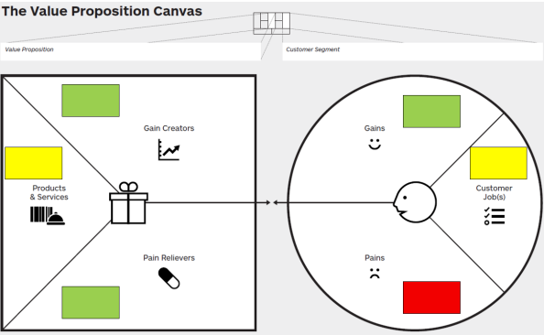
Figure 6 The Value Proposition Canvas

Yellow – for the Customer jobs and Products and services, Red – for the Pains, Green – for the Gains, Gain creators and Pain relievers.
The right side of the Value Proposition Canvas represents the customer segment’s profile. The left side represents the value map - the value which the vendor proposes to the target customer segment.
The Value Proposition Canvases for the target segments, are depicted on the next figures. They were designed based on public figures, data and reports, a number of brainstorming sessions, and consideration of the digital enterprise pillars.

Customer Jobs
Customer Jobs refer to the objectives or tasks that individuals aim to accomplish either in their professional or personal lives. These jobs encompass various aspects, such as specific tasks to be executed, challenges to be resolved, or desires to be fulfilled. It is crucial to adopt the viewpoint of the customer when analysing these jobs since what may seem significant from your perspective may not align with the actual goals customers are striving to achieve.

5.1 Trainees: Workers and unemployed;

The Value proposition to the Trainees: Workers and unemployed segment is depicted in the next Figure.

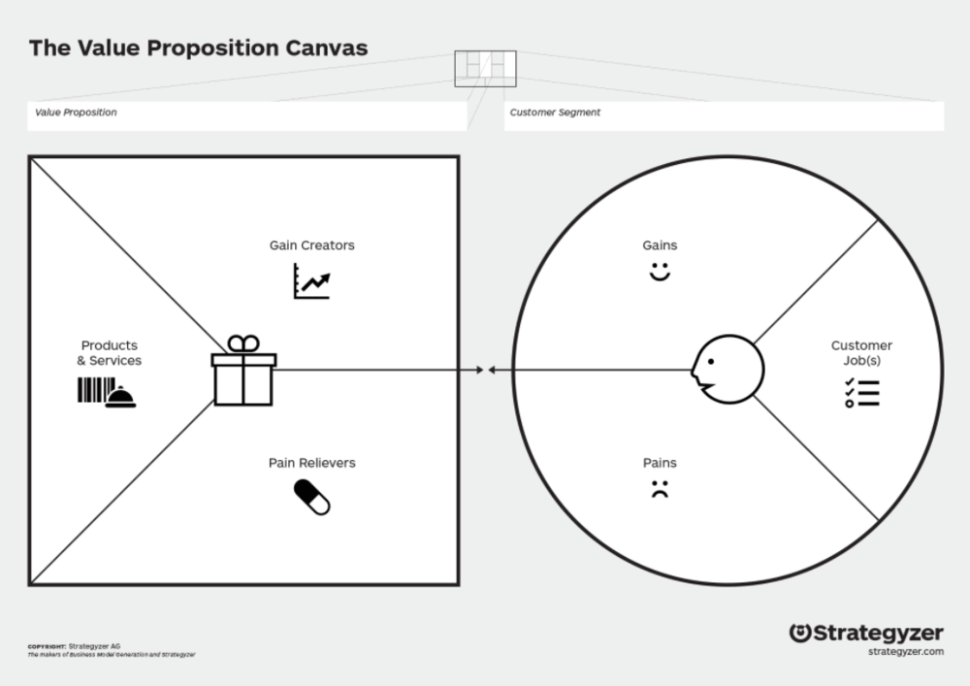
Training Programme
Students: workers and unemployed
Develop and accredit new soft and hard skills, including the digital ones, addressed to the specific needs of my job position
Improve employability/ maintain employment
Career development
Promotion/ pay raise
Losing a job/ not finding a job
Getting stuck in career
Building professional self-confidence
Get recognised
Digital isolation
Free/ paid training
Practical skills/ applicable content
Accredited (based on qualifications): Diploma, micro-credentials, degree
Soft and hard skills
Digital development
Minimizes risks: losing job, digital isolation, getting stuck in career
In-company upskilling/ reskilling training programme
Skills Accreditation
Lack of training opportunities adapted to my specific needs
Job opportunities
Personal career Development Plan
Accredited educational institution and programme
Individual curriculum tailored to the student
Face to face + digital online platform and tools
Competence configurator (AI)

Figure The Value Proposition to the Trainees: Workers and unemployed

The Customer (Segment) Profile describes the Trainee segment in our business model in a more structured and detailed way. It breaks the Trainee down into its jobs, pains, and gains.

5.1.1 Trainee Jobs
Jobs refer to the objectives or tasks that trainees aim to accomplish in their professional lives. These jobs encompass various aspects, such as specific tasks to be executed, challenges to be resolved, or desires to be fulfilled.
It is crucial to adopt the viewpoint of the trainees when analysing these jobs since what may seem significant from our perspective may not align with the actual goals trainees are striving to achieve.
According to CEDEFOP Statistics, the EU participation rate in training or education of the employed population over the employed population in 2021 is 11.6%. The minimum is 1.2% for Bulgaria, while the maximum is 33.2% for Sweden.
According to 2020 Cedefop estimates, there are 128 million adults in the EU-27 Member States, the UK, Iceland and Norway, with the potential for upskilling and reskilling (46.1% of the adult population). These adults may present low education, low digital skills, low cognitive skills or are medium-high educated at risk of skill loss and obsolescence.
According to the Infoempleo ADECCO 2021 Report, for unemployed professionals, achieving a balance between professional and personal life is the reason that weighs the most when deciding on a new job, along with professional development opportunities. One in eight unemployed believes that further studies can increase their chances of finding work. Therefore, during the time they have been unemployed, approximately 70% have done some type of training (free or paid). Regarding the most appropriate type of training to advance in their professional career, nearly 40% believe that vocational training and shorter cycles are more interesting for their training than university education. In the opinion of approximately one in three of the unemployed, the workplace is the place where this requalification should be carried out, compared to conventional educational centres.
Recognizing that not all trainee jobs hold equal significance is essential. Certain jobs hold greater importance in an employee's professional or life due to the potential serious consequences if left unaccomplished. Conversely, some jobs may be deemed insignificant because the trainee prioritises other matters over them. Taking into consideration these facts, we conclude that the key job from a trainee point of view is:
“Develop and accredit new soft and hard skills in the workplace, including the digital ones, addressed to the specific needs of the current or future job position.”

5.1.2 Trainee Pains
PAINS refer to the various factors that cause frustration or hinder employees and job seekers before, during, and after applying for a new job/ better position, attempting to accomplish their upskilling or reskilling activities, as well as those that prevent them from reaching the objectives altogether.
In many cases, even if they are interested in continuing training at work, it is difficult to find training that meets the real needs of daily work.
Pains also encompass risks associated with performing the job tasks or the training poorly or not at all.
When an employee or a job seeker does not have, or cannot demonstrate that they have, the necessary skills to carry out the activities inherent to a job position, they run the risk of losing their job.
People who do not carry out permanent training activities run also the risk of getting stuck in the development of their professional career. This is especially important in the case of digital skills, since those workers who are not able to adapt to new technologies are at great risk of getting isolated.
5.1.3 Trainee Gains
Gains describe the outcomes and benefits trainees want. These gains can be required, expected, or desired by them.
The most basic expectation we have identified is to improve employability/ maintain employment.
Once employees have secured their job to some extent, they want to progress and develop their careers. This development can lead to a promotion in the workplace and/or an increase in salary.
Another important aspect to consider is the professional recognition of their progress and the formal accreditation of the acquired skills.
All this will favour the creation of greater professional self-confidence.
The Value (Proposition) Map describes the features of a specific value proposition in our business model in a more structured and detailed way. It breaks our value proposition down into products and services, pain relievers, and gain creators.

5.1.4 Product and services
The following compilation outlines the range of products and services upon which our value proposition is founded. These offerings have been thoughtfully crafted to meet and exceed the needs and expectations of the trainees.
The training program must always be adapted to the needs of those trained as well as the job position, and be easily configurable for each particular case. To this end, it is very useful to have a competency configurator, as mentioned in previous chapters.
In the services offered, the need to provide training in person, online and mixed must be considered; so that a more practical part is included that is developed in the company's facilities.
The training program should consider both the upskilling and reskilling needs of trainees.
The training will be free for trainees, who could even receive grants, since it will be financed by companies and possible subsidies from public institutions. It should include some type of hiring commitment in case of passing the training and meeting the established requirements.
The training received will be accredited.
5.1.5 Pain relievers
Pain relievers describe how our products and services alleviate trainees' pains. They outline how we intend to eliminate or reduce some of the things that annoy the trainees before, during, or after they complete the training.
In our case, our products and services are designed to minimise the main identified risks:
- losing job: by matching skills to job positions
- digital isolation: by providing the necessary digital training
- getting stuck in career: by adapting the training programme to the specific profile of the trainee (upskilling/ reskilling).

5.1.6 Gain creators
Gain Creators illustrate the positive outcomes our products and services bring to trainees. We specifically emphasise the aspects that are pertinent to their needs, focusing on areas where our offerings can truly make a meaningful impact.
Some of the main gain creators are:
- It's important for the trainees to recognize their effort, so the training will be accredited (based on qualifications): Diploma, micro-credentials, degree.
- Free/ paid training, when subsidies are available.
- Practical skills/ applicable content.
- Soft and hard skills.
- Personal career Development Plan.
- Digital development.
- Job opportunities linked to the training provided.

5.2 Companies: Employers;
The Value proposition to the Companies’ segment is depicted in the next figure

Training Programme
Employers
Upskilling and reskilling training programme addressed at current and future employees, based on producer’s model
Competent staff = competent organization
Attractive Employer: Improve employee loyalty
Cost of developing training resources
Difficult to find training vendors that understand my industry
Proper training for partners along the supply chain
Reduce hiring costs
Lack of skilled workforce
Curricula and education process designed to support LLL
Potential public subsidies
Certification programmes
Soft and hard skills
Upskilling and reskilling programme
Reduced costs
In-company upskilling/ reskilling training programme
Get certified specialists
Training according to our own specifications
Building technical, business and soft skills
Curricula tailored to our own needs
Selected students with needed background profiles
Individual curriculum tailored to the trainee
Various forms of training (face to face, at the workplace, online support,...)
Accredited curricula and certifications

Figure The Value Proposition to the Companies’ segment

The Companies (Segment) Profile describes the Employers segment in our business model in a more structured and detailed way. It breaks the Companies down into its jobs, pains, and gains.

5.2.1 Companies Jobs
Jobs encompass the goals or duties that companies strive to achieve, aiming to enhance their competitiveness by efficiently aligning employees' skills with suitable positions. When analyzing these jobs, it becomes essential to shift the perspective from the trainees to the companies.
The main job, in this case, is to carry out an efficient upskilling and reskilling training programme addressed to current and future employees. This programme should consider building technical, business and soft skills, and should be designed according to the own company specifications.
5.2.2 Companies Pains
PAINS refer to the diverse elements that lead to employers' frustration when hiring or assigning personnel to fill new job positions, encompassing challenges encountered before, during, and after the process.
Many companies lack a skilled workforce. It's difficult to find the right profiles for new job positions and the cost of outsourcing the hiring process is too high, and does not always provide the desired result.
Companies don’t have enough resources to train new staff and it can be difficult to find training vendors that understand their industry.
Companies that don’t provide long life learning opportunities to their employees are at risk of losing talent.
5.2.3 Companies Gains
Gains represent the results and advantages sought by companies. These gains may be necessary, anticipated, or aspired by them.
The most basic expectation we have identified is to be a competent organisation with competent staff, while reducing the hiring costs.
Having staff with the required skills will cause the company to be considered attractive by both customers and future employees, making it easier to attract talent and improve employee loyalty.
This system will provide the required certified specialists, and will give the opportunity to offer proper training for partners along the supply chain
5.2.4 Product and services
This compilation outlines the range of products and services upon which our value proposition is based, crafted to meet and exceed the company's needs and expectations.
The training program must provide accredited curricula and certifications.
In the services offered, the need to provide training in person, online and mixed must be considered; so that a more practical part is included that is developed in the company's facilities.
The training program should consider both the upskilling and reskilling needs of trainees to adapt their skills to the job positions with an individual curriculum tailored to the real needs.
5.2.5 Pain relievers
Pain relievers describe how our products and services alleviate company' pains. In our case, our products and services are designed taking into account:
- Reduced costs.
- Curricula tailored to the own company’s needs.
- Selected students with needed background profiles.

5.2.6 Gain creators
Gain Creators illustrate how our products and services generate advantages for companies. We have specifically emphasised the aspects that are relevant to the companies and where our offerings can have a significant impact.
Some of the main gain creators are:
- Curricula and education process designed to support LLL
- Certification programmes
- Potential public subsidies
- Upskilling and reskilling programme

5.3 Public Administration;
The Value proposition to the Public Administration segment is depicted in the next figure

Training Programme
Public Administration
Promote training initiatives aimed at improving the employability of people with difficulties entering the labor market, improving the recruitment and retention of talent by companies and/ or solving problems to cover specific jobs
Supporting digital and sustainable transition
Promote qualified employment
Unemployment
Unfilled job offers
Improve SMEs competitiveness
Improve employees qualification
Lack of workforce with digital and green skills
Free/ paid training
Practical/ applicable content
Accredited (based on qualifications)
Soft and hard skills
Digital development
Hiring commitment
Support Skills Accreditation
Digital and sustainability trainings
Avoiding training programmes without any real demand
In-company upskilling/ reskilling training programme
Individual curriculum tailored to the trainee
Various forms of training (face to face, at the workplace, online support,...)
Accredited curricula and certifications

Figure The Value proposition to Public Administration
The Public Administration (Segment) Profile describes this segment in our business model in a more structured and detailed way, breaking it down into its jobs, pains, and gains.

5.3.1 Public Administration Jobs
Jobs pertain to the goals or responsibilities of public authorities in employment and education, aiming to enhance business competitiveness and employment rates through the effective alignment of employees' skills with job positions.
The primary task in this context is to promote training initiatives targeted at enhancing the employability of individuals facing challenges in entering the job market, while also improving talent recruitment and retention for companies, and addressing specific job gaps.
5.3.2 Public Administration Pains
As we detailed in 4.1 Analysis of existing policies and trends, some of the main pains at European level are:
- High unemployment rates
- Unfilled job offers
- Lack of workforce with digital and green skills
5.3.3 Public Administration Gains

The most basic expectations are detailed in 4.1 Analysis of existing policies and trends. Upskilling and reskilling.
- Support Skills Accreditation
- Promote qualified employment
- Supporting digital and sustainable transition
- Improve SMEs competitiveness
- Improve employees qualification
5.3.4 Product and services
When designing our value proposition we need to consider Public Administration's requirements and expectations.
- Accredited curricula and certifications
- In-company upskilling/ reskilling training programme
- Individual curriculum tailored to the trainee
- Various forms of training (face to face, at the workplace, online support,...)
5.3.5 Pain relievers
Pain relievers describe how our products and services alleviate Public Administration pains. In our case, our products and services are designed taking into account:
- Hiring commitment
- Digital and sustainability trainings
- Avoiding training programmes without any real demand

5.3.6 Gain creators
Gain Creators describe how our products and services create Public Administration' gains. We have focused on those that are relevant to the employment policies and where our products and services can make a difference.
Some of the main gain creators are:
- Employment creation
- Accredited (based on qualifications)
- Practical/ applicable content promoting digital and green skills
- Addressed to people with difficulties entering the labour market or at risk of losing jobs
- Diversification of the economy and promoting the sectors with the best prospects for the future

5.5 Value Proposition: Conclusions
The analysis of the value propositions, described above in sections 5.1 to 5.3, allow us to design a Value Proposition that addresses the three customer segments, using a multi-sided market model. We will see this in more detail in the following chapter.

Chapter 6: Business model
The business model entails using the Business Model Canvas to elucidate the components of the Producer's Model. This strategic management and lean startup template are utilised for developing new business models or documenting existing ones. The Business Model Canvas is a visual tool comprising elements that describe a company's Customer Segments, Value Propositions, Channels, Customer Relationships, Revenue Streams, Key Resources, Key Activities, Key Partnerships, and Cost Structure..
The Business model that produces and delivers the value propositions to the three customer segments is presented below.

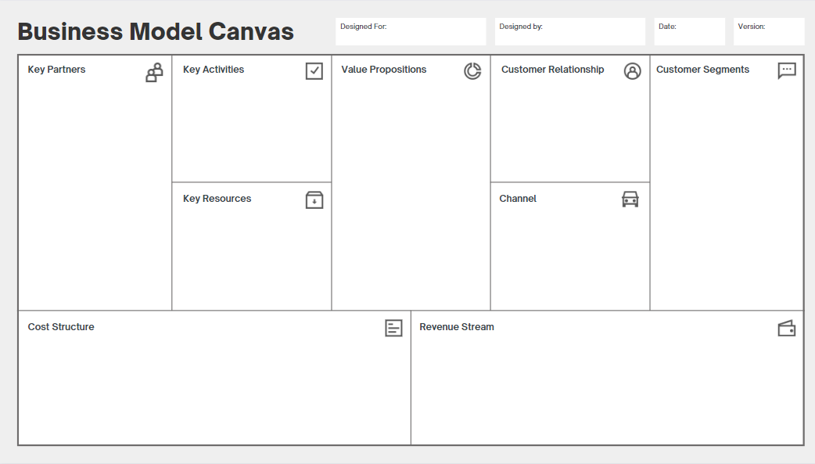
Trainees
Employees, Job Seekers, Students (Regular, VET, Dual, College, University, Polytechnic, Youth)
Companies
Companies with specific reskilling/ upskilling needs for their staff or with difficulties in finding staff with the appropriate qualifications
Public Administration
Entities of the local, regional, state or European administration that support training programs for employment
In-company upskilling/ reskilling training programme
Individual curriculum tailored to the trainee
Various forms of training (face to face, at the workplace, online support,...)
Accredited curricula and certifications
Competence configurator (AI)
Training catalogue
Webpage
Social networks
Mobile Apps
Channel partners
Schools, VETS, Colleges, HEIs
Direct marketing
Sales funnel automation
Local authorities
automated systems
human interaction
self-service
Facilities
Software and hardware
Knowledge and Intellectual Property
Human Resources
Industrial organisations (internships, skills requirements)
Labour offices
VETs, HEIs, dual-education schools
Digital technology vendors
Accreditation and Certification bodies
Business Associations/ Chambers of Commerce
Paid – B2B, B2C, Revenue share
Paid by the producer on a sales or usage fee
Pro-bono
Under Project
Subsidies
Automated processes
Education, Certification, Validation
Developing courses
Education Service Management
R & D
Production of digital education content
Producing courses
Staff
Operations
Figure The Business Model Canvas

6.1 Customer Segments
Our Customer Segments represent the diverse groups of individuals or organisations we aim to target and provide value through a dedicated Value Proposition. This includes trainees, who may not directly generate revenue but play a crucial role in the success of our business model.
Given that our model considers three potentially interdependent customer segments (companies, trainees, and public administration), with at least two of them (companies and trainees) being essential for the business model to function, we adopt a multi-sided platform approach.
Multi-sided platforms bring together distinct but interdependent customer groups, creating value by facilitating interactions among them. These platforms are valuable to one group only if the other groups are also present. In our "producer model," it is vital to attract and serve all customer groups simultaneously to create value.
We attract trainees with an inexpensive or free Value Proposition, possibly subsidised by public subsidies, to subsequently attract companies and public institutions.

6.2 Value Propositions
The Producer's Model Value Proposition describes the bundle of products and services that create value for the three analyzed Customer Segments. It is the reason why companies prefer our training company over others, why trainees are attracted to our offer, and why public institutions are willing to subsidize the training program.
The Value Proposition includes a selected combination of products and services tailored to meet the requirements of the three Customer Segments:
- Price/ cost reduction:
  - For the companies, this value proposition has a lower cost than the usual process of hiring external personnel. You can see an example approach of the costs comparison between the two options in annex 1.
  - For the trainees, this value proposition allows free access to high value-added training.
  - For the public administration, this is a low-cost way to promote qualified employment.
- Performance/ convenience/ usability:
  - For the companies, this value proposition is designed to meet the specific training needs of companies.
  - For the trainees, this value proposition is designed to allow access to a new job or help in the development of their professional career.
  - For the public administration, this value proposition follows the European guidelines for the promotion of skills and jobs.
- Technology: Use of digital technologies to design and implement the training activities. Use of e-learning platforms and mobile apps. Artificial intelligence for competences development path advisor.
- Customization: The educational institutions provide educational and training services that can be presented in service catalogues, customizable for each company and trainee. Use of a competence configurator.
- Getting the job done: all inclusive package.
- Recognition: Accreditation under EQF, NQF. Diploma, certificates.

6.3 Channels
Producer's Model Channels describe how our training company communicates with and reaches Employers, Trainees, and Public Administration Segments to deliver the Value Proposition.
The selection of channels considers the preferences and habits of each segment, and they are used not only to offer products and services but also to adjust them to the specific needs of customers.
Channels include:
- Webpage
- Social networks
- Mobile Apps
- Channel partners
- Schools, VETS, Colleges, HEIs
- Direct marketing
- Sales funnel automation
- Local authorities

6.4 Customer Relationships
Producer's Model Customer Relationships describe the types of relationships our training company establishes with specific Customer Segments.
- Long-term and interactive relationships are preferred with employers and other customer segments.
- Human interaction is essential to facilitate effective communication and support throughout the process.
- Self-service and automated systems are incorporated for student relations through the Digital Education Platform.

6.5 Key Resources
Producer's Model Key Resources describe the critical assets required to make the business model work. These resources include
Facilities: classrooms, R&D and industrial platforms and labs.
Software and hardware: computer equipment, digital education platform (web, mobile app, e-learning platform), Student’s Behavior Analyzer, Advisor Competence Configurator (AI), Business Process Automation platform.
Knowledge and Intellectual Property: Educational content in digital form under EQF, NQF, or other framework whose competencies it addresses and the correspondent subset of competences. Curricula tailored to specific industry.
Human: Every enterprise requires human resources, but people are particularly prominent in the producer's business model: Teachers, Professors, Trainers, Mentors, Assistants, Technical staff, HR Specialists, software engineers, system administrators, and specialists in specific areas like AI, BI, Big Data,...

6.6 Key Partnerships
Producer’s Model Key Partnerships Building Block describes the network of suppliers and partners that make the business model work.
Few companies own all the resources or perform all the activities described in the business models. Rather, they extend their own capabilities by relying on other firms or freelancers to furnish particular resources or perform certain activities.
Likewise, it is convenient to establish alliances with interested parties that may have common interests.
- Business Associations/ Chambers of Commerce
- Accreditation and Certification bodies
- Digital technology vendors (AI, BI, ML, Math, BPM, VR, AR, ERP ..)
- VETs, HEIs, dual-education schools
- Labour offices
- Industrial organisations (internships, skills requirements)

6.7 Key Activities
Producer’s Model Key Activities Building Block describes the most important things a training company must do to make the business model work. These activities relate to designing, manufacturing, and delivering the training programme in superior quality and efficiency.
- Education Service Management System Operation
- Developing courses under Producer’s requirements
- Education, Certification, Validation of competences
- Automated processes for individualised training
- Production of Digital Education Content

6.8 Cost structure
Producer’s Model Cost Structure describes all costs incurred to operate the business model. Some costs should be minimised by maximum automation, and outsourcing of non essential activities, while keeping some costs focused on value creation.
The main costs will be:
- R & D
- Production of digital education content
- Producing courses
- Staff
- Operations

6.9 Revenue Streams
Producer’s Model Revenue Streams represent the ways your company generates revenue from each Customer Segment.
- Pro-bono: Though the “producer model” incurs costs by serving all customer groups, it lures trainees segment with an inexpensive or free Value Proposition in order to subsequently attract them, subsidised by the state, awards, scholarships
- Paid by the producer on a sales or usage fee (the more the service is used, the more the company pays)
- Paid – B2B, B2C, Revenue share
- Under Project

Chapter 7 Summary
This report represents “O3 - Business model for aligning the adults training programs to the needs and opportunities offered by the labor market and specific organizations upon producer’s model”, the third of the Digital Education Enterprise project’s outputs. It was developed within the project 2021-1-BG01-KA220- ADU-000026986 “Digital transformation: from adult-education institution to Digital Education Enterprise”, funded with the support from the European Commission.
The methodological framework used for the development of this output consists of three steps:
- Identification of target groups under Producer’s Model: 3 customer segments were identified.
- Design of value propositions to all segments identified at step 1, based on Producer´s Model. Detailed value propositions were developed for these customer segments. We used The Value Proposition Canvas for this purpose. It is a convenient business tool to design and communicate value propositions.
- Design of Producer’s Business models, which produce and deliver the Value propositions devised at step 2. The analysis of the developed value propositions showed that they could be developed using a multi-sided market model. We used The Business Model Canvas for this purpose. It is a convenient business tool to design and communicate business models.

Bibliography
- Strategyzer, AG. Strategyzer. www.strategyzer.com. [Online] Strategyzer AG, 2010. [Cited: 04 19, 2022.] https://www.strategyzer.com/canvas/business-model-canvas
- Strategyzer, AG. Strategyzer. www.strategyzer.com. [Online] Strategyzer AG, 2014. [Cited: 04 19, 2022.] https://www.strategyzer.com/canvas/value-proposition-canvas
- Council of the European Union. (2020). Council Recommendation of 24 November 2020 on vocational education and training (VET) for sustainable competitiveness, social fairness and resilience (2020/C 417/01). Official Journal of the European Union. https://eur-lex.europa.eu/legal-content/EN/TXT/?uri=CELEX%3A32020H1202%2801%291
- European Commission. (2022). Commission adopts proposal to make 2023 the European Year of Skills. https://commission.europa.eu/strategy-and-policy/priorities-2019-2024/europe-fit-digital-age/european-year-skills-2023_en
- European Commission. (2021). Digital skills and jobs. Retrieved July 24, 2023, from https://digital-strategy.ec.europa.eu/en/policies/digital-skills-and-jobs
- European Commission. (2021). Europe’s Digital Decade: Digital targets for 2030. Retrieved July 24, 2023, from https://ec.europa.eu/info/strategy/priorities-2019-2024/europe-fit-digital-age/europes-digital-decade-digital-targets-2030_en
- European Commission. (2021). Pact for Skills. Retrieved July 24, 2023, from https://pact-for-skills.ec.europa.eu/index_en
- European Commission. (2021). European Skills Agenda. Retrieved July 24, 2023, from https://ec.europa.eu/social/main.jsp?catId=1223
- European Commission. (2021). Digital Skills and Jobs Coalition. Retrieved July 24, 2023, from https://digital-skills-jobs.europa.eu/en/about/digital-skills-and-jobs-coalition
- European Centre for the Development of Vocational Training. (2021). Home. Retrieved July 24, 2023, from https://www.cedefop.europa.eu/
- World Economic Forum. (2023). The Future of Jobs Report 2023. Retrieved July 24, 2023, from https://www.weforum.org/reports/the-future-of-jobs-report-2023/
- Reskilling for Employment. (2021). Home. Retrieved July 24, 2023, from https://reskilling4employment.eu/
- Hellenic Federation of Enterprises. (2021). Skills4Jobs. Retrieved July 24, 2023, from https://www.sev.org.gr/protovoulies-kampanies/skills4jobs/
- European Centre for the Development of Vocational Training. (2021). Skills for green jobs: 2021 update. Retrieved July 24, 2023, from https://www.cedefop.europa.eu/files/9174_en.pdf
- European Centre for the Development of Vocational Training. (2021). European skills index 2021. Retrieved July 24, 2023, from http://www.cedefop.europa.eu/en/publications-and-resources/publications/3081
- Infoempleo & Adecco. (2021). Informe Infoempleo Adecco 2021: Oferta y demanda de empleo en España. Retrieved July 24, 2023, from https://cdnazure.infoempleo.com/infoempleo/documentacion/Informe-infoempleo-adecco-2021.pdf

ANNEX1: Producer’s Model Business Case

