Digital transformation: from adult-education institution to Digital Education Enterprise

O4 Digital training manual

How to implement O1 and O3 business models, and O2 Digital Transformation Plan and processes

Project data
Project title Digital transformation: from adult-education institution to Digital Education Enterprise

Project acronym Digital Education Enterprise

Project number 2021-1-BG01-KA220-ADU-000026986

Project coordinator E10142644 SBC School of business competences Ltd.

Partner organization E10268592 Mobiliz Bilgi Ve İletişim Teknolojileri A.Ş.
E10209310 Instituto Tecnologico De Canarias, S.A.
E10032547 Dorea Educational Institute
E10150580 Business & Professional Women CR Z.S

Project result title O4 Digital training manual How to implement O1 and O3 business models, and O2 Digital Transformation Plan and processes

Document category Learning / teaching / training material – Manual / handbook /guidance materiál

Within responsibility [A] SBC [A] BPWCR, [C] Partners
of R=Responsible - those who do the work to complete the task
A=Accountable - the one ultimately answerable for the correct and thorough completion of the deliverable or task
C = Consulted – those whose opinions are sought
I= Informed – Those who are up-to-date on progress

Date of issue October 28, 2022
Version NN.NN 01.01

Audience Project partners, public under ERASMUS+ rules

Result Description

O4 is a Digital training manual how to implement O1 and O3 business models, and O2 Digital Transformation Plan and processes O4 is in a form of presentation, video and text files Target groups - The partners in this project - Adult education and training organizations –commercial and in-company - Trade and/or industrial association, employers, and labour agencies searching for curricula aligned to their specific needs and labour market opportunities - Start-ups in area of adult digital education and training = Adults searching for upskills pathways at their current workplace or for individualized curricula - VET and other educational organizations interested in new digital education business models - Social groups with limited access to digital technologies and content Needs analysis – The implementation of O1 to O3 results requires organizational and technical efforts. Part of them are related to training and informing the interested parties how to perform the implementation - In some cases, the implementation could be complex and involve a lot of people. Then training people on specific aspects of implementation becomes mandatory - Be believe the O1 to O3 products have good chances for dissemination. The digital training stuff to promote the O1 to O3 products and help implementation is necessary Expected impact - This O4 guide will make it easier the implementation of O1 to O3 products in partnership organizations and other interested parties - O4 has the opportunity to provide scenarios for Value proposition and Business models design - O4 may impact bigger companies approach to training for their specific agenda and improve cooperation - O4 may impact organization from different sectors, motivating them to perform reengineering toward digital enterprise - Catching up with digitalization- Transferability potential The O4 product has good chances in this area, because provides business cases for real business models development. The training for any of O1 to O3 is interesting in case of implementation as well.

Scope

O4 Digital training manual how to implement O1 and O3 business models, and O2 Digital Transformation Plan and processes
Traditional approach and Focus on product principle to design the syllabus will be applied. The training will comprise at least 3 modules dedicated to O1 ti O3
The result is Syllabus. O4-T2 Design of the course ([A]BPWCR, [C] Partners) For the purpose: - Presentations, Exercises, Business cases will be prepared The result is a complete set of Digital Education Enterprise business model’s processes O4-T3
Test training ([A] BPWCR, [C] Partners) Test training to the partners staff will be conducted to test the Manual and prepare partners for appropriate implementation Corrective action will be done Improved version of the manual will be produced O4-T4 Preparation of video version of the manual ([A] BPWCR, [C] partners) Available video recording tools will be used O4-T5 Publish the stage results at project’s website ([A] SBC, [I] partners.

Project data 2
Result Description 3
Scope 3
Digitalization Smart Process in Education Enterprise 5
Business Model Canvas 6
Target Group 6
Value Proposition Fit 6
Channels 8
Customer Relationships 9
Revenue Streams 9
Key Resources 9
Key Activities 10
Key Partnerships 10
Cost Structure 11
Successful implementation of Canvas 11
Performance and Control of the Digitalization Process 12
Potential Areas for Improvement 12
10 Cases of Digitalization in Education 14
List of some well known educational companies 16
Practical Cases of Partners 17
Case 1 Catalog of Trainings and Hook 17
Case 2 Digital Maturity Assessment 17
Case 3 Play Roles and Simulation of Real Case Scenario 17
Case 4 Transition from Analogue to Digital Era in Education Company 17
Conclusion 18
Literature: 18

Digitalization Smart Process in Education Enterprise

in the education enterprise refers to the integration of digital technologies into various aspects of education, including teaching, learning, assessment, administration, and communication. This process involves the use of various tools, platforms, and software applications to create, manage, deliver, and consume educational content and services.

Overall, the digitalization process in the education industry has the potential to transform the way we manage, teach and learn, making company process more effective, preparing education more accessible, engaging, and effective for learners of all ages and backgrounds.

For a successful digitalization process in an educational company, it is recommended to start with an assessment to well describe actual company and educational processes, identifies areas that can benefit from digitalization, and sets clear objectives for the digital transformation.

After infrastructure inventory, such as high-speed internet, reliable network systems, and appropriate hardware (computers, tablets, projectors, etc.) and then software and application selection, it is needed to start with a training and capacity building for teachers, staff, and administrators to ensure they are equipped with the necessary skills to effectively use digital tools and integrate technology into their managing, teaching and administrative tasks.

The educational company regularly evaluates the impact of digitalization efforts, collects feedback from stakeholders, and makes necessary adjustments and improvements to optimize the use of technology and digital resources.

By undergoing the digitalization process, an educational company can enhance teaching and learning methods, promote active student engagement, facilitate personalized learning experiences, streamline administrative tasks, and provide a more accessible and inclusive education for all students.

Before embarking on the digitalization journey, it is crucial for a company to raise awareness and ensure a comprehensive understanding of the process and its implications. By effectively communicating internally and externally about digitalization, an educational company can build trust, generate interest, and garner support from employees, students, stakeholders, while also showcasing their commitment to providing a modern and effective learning environment.

Business Model Canvas

The Canvas business model is a strategic tool used by entrepreneurs and businesses to asses, visualize and outline the key components of their business in a concise and structured manner. It consists of a single-page template called the "Business Model Canvas."

The Canvas is divided into nine essential building blocks that cover all aspects of a business strategy. To start the Business Model Canvas is recommended to breakdown and analyze each of all nine building blocks.

A good way to approach this is to gather the heads from marketing, sales, operations, finance, and manufacturing (if product-based) and pencil-in a time where you can all meet together.

Then, after drawing a first version of canvas onto a whiteboard, proceed to dissect and discuss each of the 9 building blocks as they relate to related business. Smart usage of sticky notes shows and organizes thoughts around the canvas.

Target Group

is an essential component that refers to the specific customer segment or group of people that a business aims to serve and cater to with its products or services. Identifying and understanding the target group is crucial for creating a successful business strategy and ensuring that the company's offerings align with the needs and preferences of the intended customers.

Determine which customer segments are the most suitable or responsive to the value proposition your business offers. Your value proposition should address the unique needs and pain points of these target groups.

Value Proposition Fit

refers to the alignment between a company's value proposition and the specific needs, desires, and pain points of its target customer segments. It is a crucial aspect of the canvas model because without a strong value proposition fit, a business may struggle to attract and retain customers.

Overall, the Value Proposition Fit is about ensuring that what a business offers matches what its customers want, creating a win-win situation for both the company and its clients. It significantly increases the chances of success and customer loyalty, leading to sustainable growth and profitability for the business.

Canva's value proposition lies in its ability to provide a user-friendly and versatile platform for creating and designing visual content. This can be effectively utilized by educational companies for successful digitalization. This component outlines the specific benefits that digitalization can bring to the educational institution. These benefits may include improved learning outcomes, increased access to educational resources, reduced costs, and enhanced student engagement.

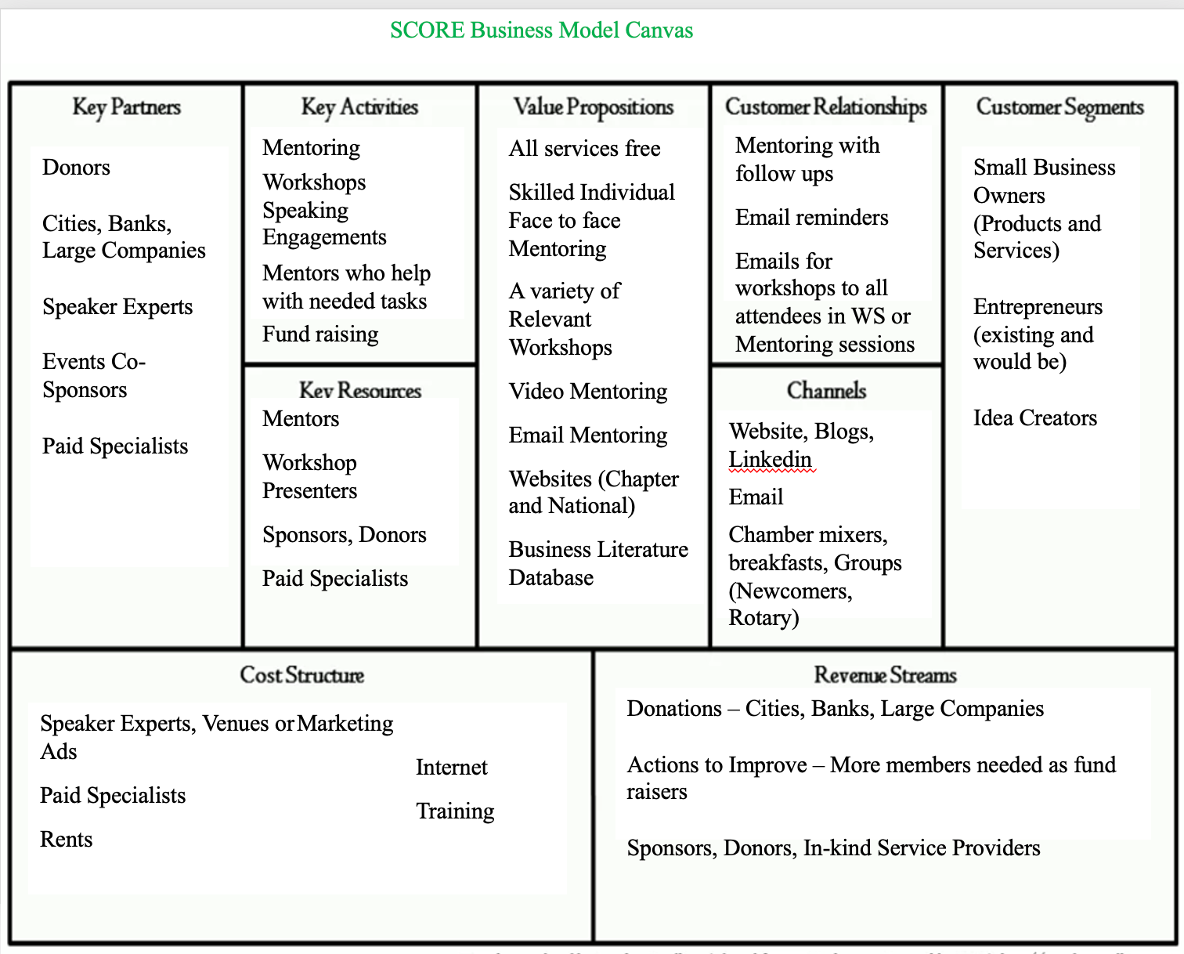
Picture 1. Business Model Canvas Template

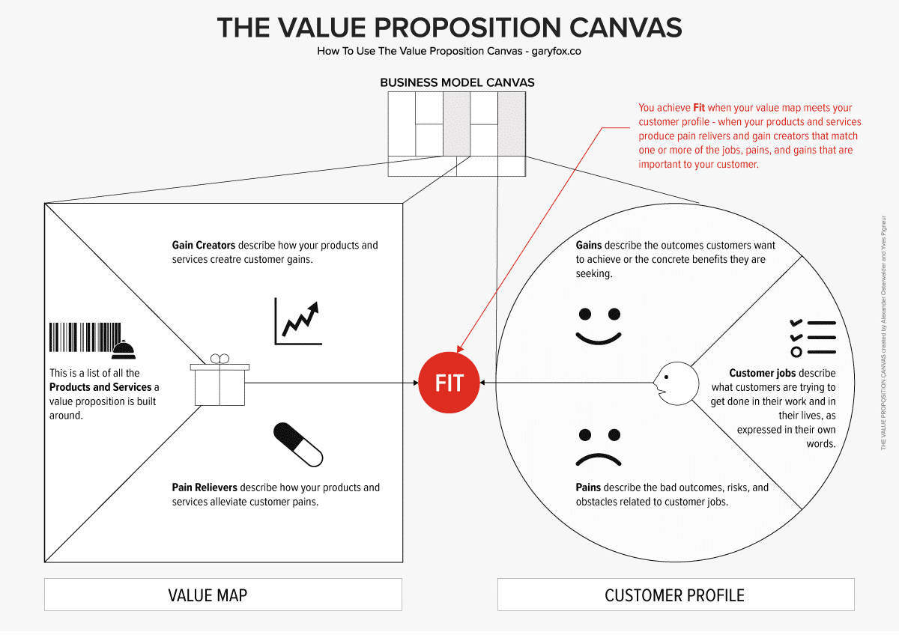
Picture 2. Value Proposition Template

Channels

component refers to the various ways a business uses to deliver its products or services to its target customer segments. This building block outlines the distribution and communication channels that connect the company with its customers. It is crucial for a business to select the most effective and efficient channels to reach and interact with its customer base. Selecting the right mix of channels is vital as it directly impacts a business's ability to connect with its customers, generate sales, and maintain customer satisfaction.

The Channels component of the Canvas should be aligned with the Value Proposition and the needs of the chosen Customer Segments to create a successful and effective business model.

The marketing, sales, and distribution channels educational company uses provide specific service to your customer. These channels may include email, social media, websites, and other online platforms in education segment.

Customer Relationships

component refers to the types of relationships a business establishes and maintains with its customers. This building block is essential for understanding how a company interacts with its target customers and how it delivers value to them while fostering customer loyalty and satisfaction.

Personal assistance, collaboration with partners, long terms relationship, self-service, problem solving etc. are several types of customer relationships that a business can adopt, depending on its industry, products or services, and overall business strategy. The choice of customer relationship types will depend on the nature of the business, the preferences and expectations of the target customers, and the overall customer experience strategy. Effective customer relationships can lead to increased customer retention, higher levels of customer satisfaction, and positive word-of-mouth, which can all contribute to the business's long-term success.

Canva's collaboration features enable educators and students to work together on projects, share feedback, and stay organized, even when working remotely.

Revenue Streams

component outlines the sources of revenue and how a business generates income. This building block is crucial for understanding the different ways a company makes money and sustains its operations.

When filling out the Revenue Streams section, businesses identify the various sources from which they derive income. The choice of revenue streams depends on the business model, target market, and the value proposition offered to customers. Diversifying revenue streams can be beneficial for reducing risks and increasing overall revenue stability. A successful business often optimizes its revenue streams to ensure a healthy balance between profitability and customer satisfaction.

Key Resources

component refers to the critical assets, resources, and capabilities that a business requires to operate effectively and deliver its value proposition to its target customers. These resources are the foundation of the company's operations and are essential for achieving its key activities and objectives.

Identifying and managing Key Resources is crucial for ensuring that a business can efficiently deliver its value proposition and maintain a competitive edge in the market. It involves assessing which resources are critical, allocating resources wisely, and potentially developing or acquiring new resources as the business grows and evolves. Moreover, understanding the Key Resources helps business leaders optimize their operations and make strategic decisions to maximize efficiency and effectiveness.

Key Activities

component refers to the core activities and processes that a business needs to carry out to deliver its value proposition to its target customers. These activities are the essential tasks and operations that enable the business to create, produce, and deliver its products or services, as well as maintain its customer relationships and overall operations.

Key Activities can vary significantly depending on the nature of the business and education industry.
The Key Activities are closely connected to the Value Proposition and other components of the Business Model Canvas. They represent the operational backbone of the business, and their effectiveness and efficiency directly impact the delivery of value to customers and the overall success of the education enterprise.

When working on the Business Model Canvas, it's crucial for businesses to identify and prioritize their Key Activities to ensure they align with the Value Proposition and other elements of the model. By doing so, they can focus on optimizing these core activities and processes to create a competitive advantage and achieve their business objectives.

Key Partnerships

component refers to the external entities or organizations that a business collaborates with to enhance its operations, expand its capabilities, and create mutual value. These partnerships can play a crucial role in the success and growth of a business by leveraging the strengths and resources of each partner. Key Partnerships can take various forms, and the choice of partners depends on the business's strategic objectives and the nature of its industry.

Key Partnerships can bring several benefits to a business, such as accessing new markets, sharing risks and costs, gaining a competitive advantage, accelerating innovation, and strengthening the overall value proposition. However, it's essential to choose partners carefully and ensure alignment in goals, values, and expectations to foster successful and productive collaborations.

When working on the Business Model Canvas, identifying and establishing Key Partnerships can significantly impact a company's ability to deliver value to its customers and achieve its strategic objectives effectively.

Cost Structure

component refers to the expenses and costs associated with running the business and delivering its value proposition to customers. Understanding the cost structure is essential for assessing the financial viability and profitability of the business model.

Costs can be classified into two main categories:
Fixed Costs that remain relatively constant regardless of the business's level of activity or sales. Examples of fixed costs include rent, salaries of permanent employees, insurance, administrative expenses, and certain types of technology infrastructure. Variable Costs are directly related to the business's level of activity or production volume. Examples of variable costs include raw materials, production labor, sales commissions, shipping costs, and some marketing expenses.

To complete the Cost Structure section of the Business Model Canvas, businesses need to identify and categorize their fixed and variable costs, estimate their values, and consider how these costs may change as the business scales or adapts to market conditions. It's crucial for businesses to regularly review and update their cost structure as their operations evolve and market dynamics change. This ensures that the business remains competitive, sustainable, and financially sound.

Successful implementation of Canvas

To successfully implement Canva in an educational company's digitalization strategy, consider the following steps:

Provide educators and students with training and resources to familiarize them with Canva's features and functionalities. Offer ongoing support to address any questions or concerns.
Develop clear and suitable guidelines or templates that align with the company's educational goals and brand identity. Encourage employees, educators and students to follow these guidelines to maintain consistency across all materials.

Encourage collaboration among educators and students by utilizing Canva's collaboration features. Foster a feedback culture to ensure continuous improvement and quality of the created content.
Explore and integrate Canva with existing educational systems, such as a learning platform, to streamline workflows and make it easier for educators and students to access and share their creations.
Encourage students to actively engage in the content creation process using Canva. Assign projects that require them to create visually engaging materials, fostering creativity and enhancing their digital skills.

By leveraging Canva's intuitive design, versatile content creation capabilities, collaboration features, and customization options, educational companies can successfully embrace digitalization and enhance the overall learning experience for both educators and students.

By raising awareness and effectively communicating the benefits, goals, and strategies of digitalization, a company can build a solid foundation for successful transformation. It is important to ensure that all stakeholders understand the purpose and potential of digitalization and are actively engaged in the process.
External communication about digitalization in an educational company plays a crucial role in informing and engaging stakeholders outside the organization.

Performance and Control of the Digitalization Process

in an educational company are essential for ensuring its effectiveness, monitoring progress, and making informed decisions. By implementing robust performance and control measures, an educational company can effectively manage the digitalization process, ensure its success, and make informed decisions to optimize teaching and learning outcomes.

While Canva can assist in creating visual representations of your business model, it is essential to remember that the design is merely a tool to convey the underlying concepts and ideas of your business model effectively. The focus should be on creating a clear and concise representation that effectively communicates the key aspects of your business model to your intended audience.

Potential Areas for Improvement

Here are some potential areas for improvement in an educational company.
An educational company can switch various aspects of its operations and educational processes to digitalization.

- Learning Management System (LMS): Implement an LMS to manage and deliver course content, assignments, assessments, and student progress tracking. It provides a centralized platform for teachers and students to access learning materials, participate in discussions, and submit assignments online.

- Online Learning Platforms: Develop or adopt online learning platforms or virtual classrooms where students can access course materials, engage in interactive learning activities, and collaborate with peers and teachers in real-time.

- Digital Content and Resources: Transition from traditional textbooks to digital content and resources, such as e-books, interactive multimedia materials, online libraries, educational apps. Digital content can be easily updated, personalized, and accessed from anywhere, enhancing the learning experience.

- Assessments and Grading: Utilize digital assessment methods, such as online quizzes, interactive assignments, and automated grading systems. Digital assessments enable instant feedback, personalized recommendations, and efficient grading processes.

- Communication and Collaboration: Foster digital communication and collaboration among students, teachers, and parents through platforms like email, messaging apps, discussion boards, and video conferencing tools. This facilitates easy and timely communication, enables virtual group work, and enhances parental involvement. Implementation of digital platforms to enhance their engagement, such as parent portals, online progress reports, and communication apps.

- Data Analytics and Personalized Learning: Utilize data analytics to track student progress, identify learning gaps, and provide personalized learning experiences. Digital tools can collect data on student performance, engagement, and learning patterns, enabling targeted interventions and adaptive learning pathways.

- Administrative Tasks: Streamline administrative tasks through digital tools, such as student information systems, online registration systems, digital attendance tracking, and automated reporting systems. This reduces paperwork, improves data accuracy, and increases administrative efficiency.

- Professional Development: Provide online professional development opportunities for teachers and staff, including webinars, online courses, and virtual workshops. Digital platforms enable access to a wide range of educational resources and foster continuous learning for educators.

- Virtual Simulations and Labs: Incorporate virtual simulations and online laboratory experiences to supplement hands-on learning in subjects like science, engineering, and healthcare. Virtual simulations provide realistic and immersive environments for students to practice skills and conduct experiments.

These are just a few examples of how an educational company can switch to digitalization. The specific areas of digital transformation may vary based on the company's objectives, resources, and educational focus. It's important to carefully plan and prioritize digital initiatives based on the needs and goals of the company and its learners.

10 Cases of Digitalization in Education
Digitalization in education refers to the integration of digital technologies and tools into the teaching and learning processes. It involves the use of computers, the internet, software applications, online platforms, and other digital resources to enhance and transform traditional educational practices.
Cases of digitalization in education have had a profound impact on various aspects of the educational ecosystem. Despite its many benefits, digitalization in education also comes with challenges. These include the digital divide (unequal access to technology), concerns about data privacy and security, ensuring the quality of online content, and the need for teacher training in effectively integrating technology into the classroom.
- Access to Information: Digitalization has made information more accessible than ever before. Students can access a vast amount of educational content, research articles, e-books, and online courses from anywhere with an internet connection. This increased access has democratized education and provided opportunities for learners in remote or disadvantaged areas.

- Online Learning Platforms: The rise of online learning platforms, Massive Open Online Courses (MOOCs), and learning management systems (LMS) has enabled learners to enroll in courses from universities and institutions worldwide. These platforms offer a flexible learning experience, allowing individuals to study at their own pace.

- Personalized Learning: Digital tools and adaptive learning technologies can analyze individual student performance and cater to their specific learning needs. This personalized learning approach helps students learn more effectively and efficiently.

- Interactive Learning: Digitalization has introduced interactive learning methods such as multimedia presentations, simulations, virtual reality (VR), and gamification. These engaging approaches make learning more enjoyable and enhance knowledge retention.

- Collaborative Learning: Digital technologies facilitate collaboration among students, teachers, and experts across geographical boundaries. Virtual classrooms, discussion forums, and collaborative tools encourage peer learning and knowledge exchange.

- Teacher Professional Development: Digitalization has extended beyond student learning and is also being utilized for teacher professional development. Online workshops, webinars, and educational resources help teachers enhance their skills and stay updated with the latest pedagogical practices.

- Assessment and Feedback: Digital assessment tools streamline the evaluation process and provide immediate feedback to students. Automated grading systems for multiple-choice questions, quizzes, and assignments help teachers manage large classes efficiently.

- Resource Management: Schools and educational institutions use digital systems to manage administrative tasks, including enrollment, attendance tracking, grade management, and communication with parents.

- Inclusive Education: Digital technologies have the potential to make education more inclusive for learners with disabilities. Specialized software, assistive devices, and accessibility features improve learning opportunities for all students.

- Data-Driven Education: Digitalization generates vast amounts of data on student performance and learning patterns. Analyzing this data helps identify areas for improvement and enhances decision-making in education.

In conclusion, the case of digitalization in education has brought significant advancements and improvements to the learning experience. As technology continues to evolve, it is likely to play an even more crucial role in shaping the future of education.

List of some well known educational companies
Several educational companies have been embracing digitalization to enhance learning experiences and expand their reach. Here are some well-known educational companies that were actively involved in digitalization:
Coursera: An online platform offering a wide range of courses from top universities and institutions worldwide. https://www.coursera.org/

Udemy: A marketplace for online courses, where instructors can create and sell their educational content. https://www.udemy.com/

LinkedIn Learning: Provides online courses and video tutorials aimed at professional development and career advancement. https://www.linkedin.com/learning/

Duolingo: A language-learning platform offering interactive courses to learn different languages.
https://cs.duolingo.com/

Codecademy: Focuses on coding and programming education with interactive lessons and coding challenges. https://www.codecademy.com/

edX: A massive open online course (MOOC) provider, offering courses from renowned universities and institutions. https://www.edx.org/

Skillshare: An online learning community where creators share their knowledge through video-based courses. https://www.skillshare.com/

Pluralsight: Specializes in technology and IT-related courses, providing skill development for professionals. https://www.pluralsight.com/product/skills

MasterClass: Provides classes taught by celebrities and experts in various fields, such as cooking, writing, and filmmaking. https://www.masterclass.com/

Teachable: A platform that allows individuals and institutions to create and sell their online courses. https://teachable.com/
And many more, every day we can find a new application, a new potential, a new modern digital education project, a digital project in every industry.

Practical Cases of Partners

Case 1 Catalog of Trainings and Hook

Case 2 Digital Maturity Assessment

The implementation of IO2, as recommended by our partner Dorea, should involve the use of an assessment of digital maturity. For example the Digital Maturity Assessment tool provided by Digital Leadership Ltd. This assessment tool is designed to help organizations evaluate and understand their level of digital maturity. While originally intended for charities and non-governmental organizations (NGOs), it is also available for use by other types of organizations. http://digitalmaturity.org/assessment/

The Digital Maturity Assessment categorizes an organization's digital maturity into different levels, which range from 1 (low) to 5 (high). The purpose of this assessment is to provide a clear picture of how well an organization has embraced digital technologies and practices in its operations and strategies.

Completing the assessment is a relatively quick process, taking approximately 10 to 15 minutes. During the assessment, participants are presented with descriptions and questions that pertain to various aspects of digital maturity. These questions are designed to help organizations self-assess and determine where they currently stand in terms of digital readiness and adoption.

By using this tool, organizations can gain valuable insights into their digital capabilities and identify areas for improvement. This information can then be used to inform strategic decisions and initiatives aimed at enhancing their digital maturity, ultimately helping them adapt and thrive in an increasingly digital world. Whether an organization is a charity, NGO, or any other type of entity, the Digital Maturity Assessment offers a valuable opportunity to gauge and enhance its digital readiness.

Case 3 Play Roles and Simulation of Real Case Scenario

Case 4 Transition from Analogue to Digital Era in Education Company

BPWCR implements a Digital Education Enterprise project to describe all aspects of smart integration and digitalization in the company. The project goals show high importance of business model needs for a target group and key activities determination. As a very important point we see an emphasis on the sociological insight for understanding the importance of digitalization in the educational industry and the sensitive support of employees, teachers and students.

Conclusion

We can conclude that our educational companies are committed to transforming the learning landscape from analogue to digital era by providing innovative and personalized educational solutions that empower learners of all ages to reach their full potential. Through our comprehensive curriculum, cutting-edge technology, and expert educators, we strive to create a supportive and inspiring learning environment that fosters curiosity, critical thinking, and a love for learning.

By forging strategic partnerships with educational institutions, content providers, and technology companies, we aim to expand our reach and impact, making quality education accessible to students worldwide. Our cost-efficient operations and continuous investment in research and development allow us to deliver exceptional value to our students while ensuring the long-term sustainability and growth of our company.

As we continue to evolve and adapt to the changing educational landscape, our unwavering commitment to excellence remains at the core of our mission, driving us to shape a brighter future for education.

Literature:

We have used the ChatGPT application for a frame of this manual.

https://business.udemy.com/
https://www.coachhub.com/
https://www.strategyzer.com/
https://www.garyfox.co/
https://www.score.org/
https://drive.google.com/file/d/1pIUuXCgdVklVxmZrLh45OzfS_Qmah7D0/view?usp=drive_link

